- Volume 1 | Issue 25  February 19, 2026 |   Newsletter of the
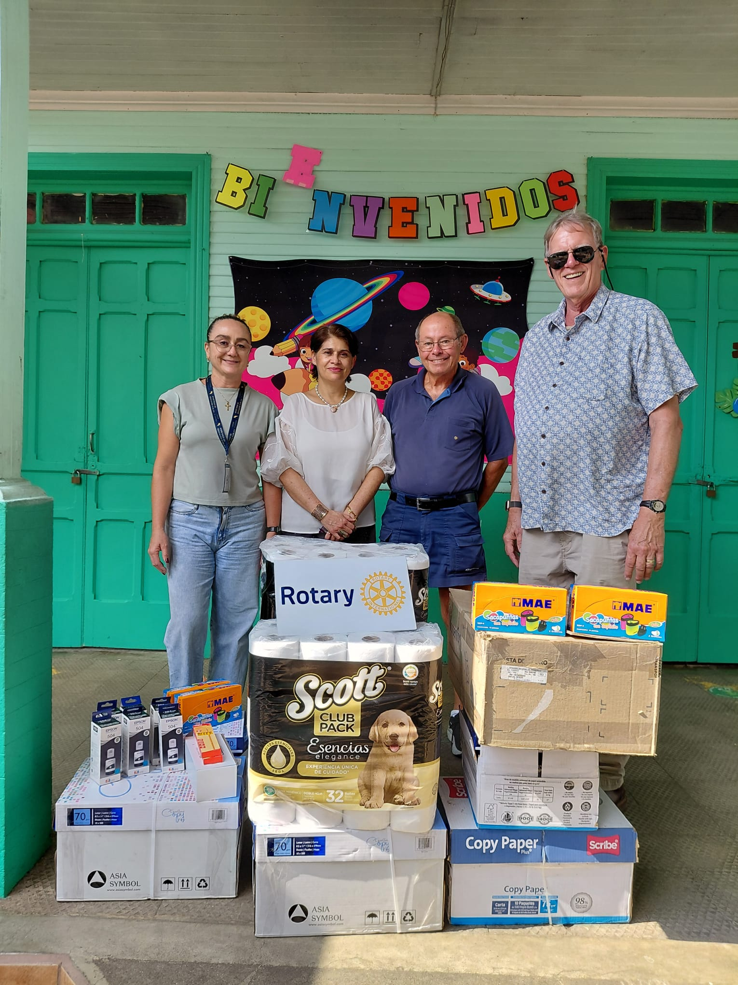    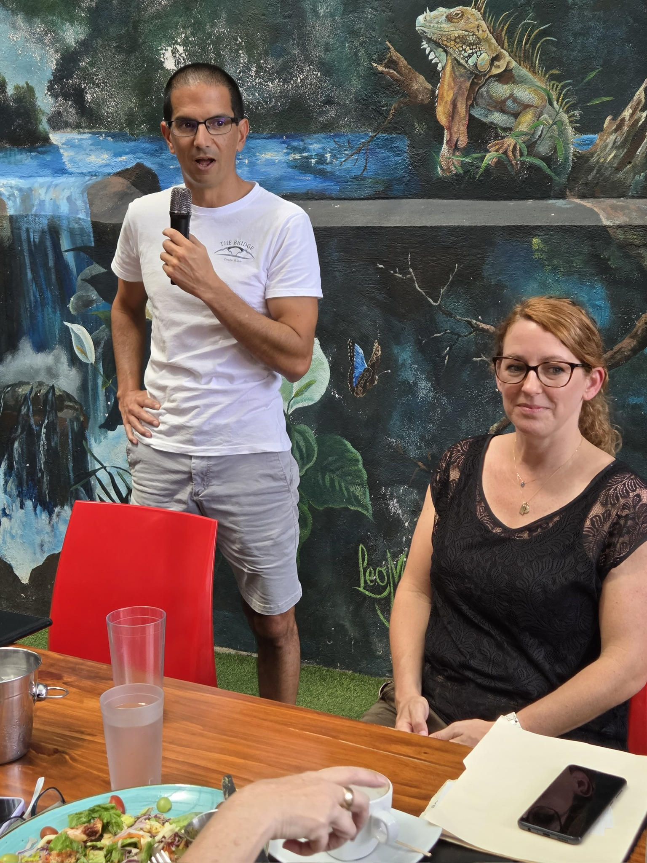 | Even the smallest act of caring for another person is like a drop of water -it will make ripples throughout the entire pond. ~ Jessy and Bryan Matteo  Meeting Highlights  We welcomed Nancy P, who is considering applying for membership, and Heather and Danny from The Bridge as our guests.  David updated us on the school desk project. While visiting the school he found out that the school in Barrio Jesus has very little money for school supplies. Kids will be starting school this coming Monday and they don’t have ink for the printers, paper, pencils, or pencil sharpeners. Teachers must even bring their own toilet paper. Some parents donate around 1,000 colones a month for school supplies but it doesn’t buy much. Our board approved using up to $500 of our fundraising budget to contribute to purchasing supplies. The Club then voted unanimously to buy supplies for this school. Our club will match member donations up to $500. Give the money to Stef for the school supplies or you can SINPE Movil at 6469-3427 (Be sure to note it’s for school supplies).  Lynn will send us a link with a brief online questionnaire later this week. This is an opportunity for you to give input about our meetings, projects, and anything else you’d like to suggest about the club. Please respond quickly to avoid delays in scheduling future meetings and presentations.  Eric hopes to have a draft of the bylaws ready for review at our next meeting.  During the BINGO update, Lynn emphasized that the IB program we’re partnering with gets zero funding and support from the local high school. These students are learning that it’s not always what you know, but who you know, that can make a difference. We introduced the idea of forming an Interact Club, which is Rotary Club for youth, to expand their resources and opportunities. Lynn will be sending out a list of suggestions for bingo prizes. Nancy will store our donations and keep a spreadsheet about who has been approached for donations. This way we can avoid duplicating our efforts.  Nancy will bring back Rotary t-shirts for us from the states. It’s $20 a shirt. If you’d like one, contact Nancy asap with your size.  Guest Speakers  Our guest speakers were Heather Tracy, CEO of the Bridge Program and Danny Ricio, Director. New Summit Academy is also part of their program. Their mission aligns with ours in their desire to make a difference in the community. Their relationships also extend into the indigenous community. The Bridge may be interested in working with Rotary to create opportunities that will provide their young adults with experiences that make an impact in the community.  The Bridge works with young adults who often have poor self-images. Through the projects and internships the program offers, they learn to gain confidence and discover their abilities.  The program emphasizes the importance of doing things that matter in the community. It works with the schools and other learning institutions.
Officers &  Committee Chairs  President  Eric Snyder  President Elect  Russell Herold  Treasurer  Stephanie Bogatinoff  Secretary  Lynn Snyder  Sgt-at-Arms  Mary Beth Clark  Foundation Chair  Chris Toal  Membership  OPEN  Newsletter  Rosalie Olds  Joe Rossi  PR/Website  Leslie Mueller  Programs  OPEN  Sunshine Committee  Betty Van Putten  Fundraising  OPEN  Club Events  Judy Tiktin  Nancy Rees  Outreach  David Mullins  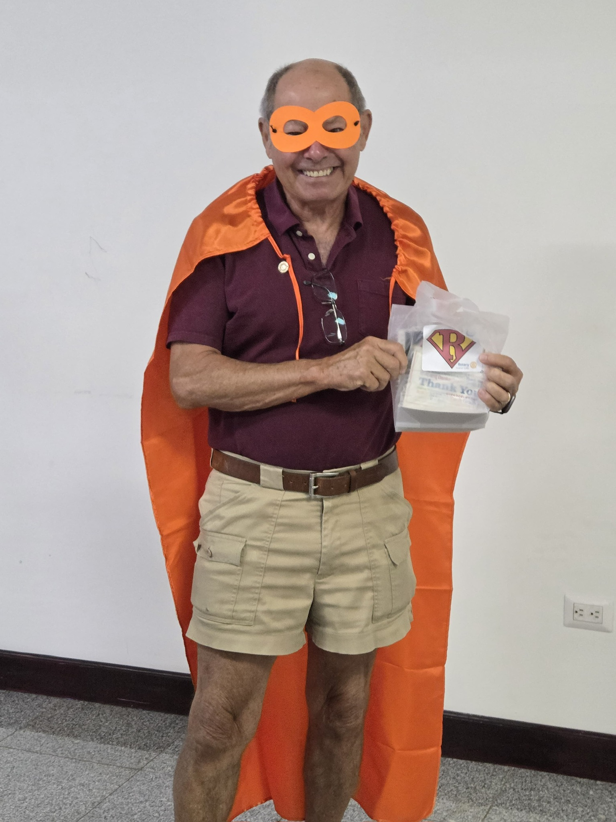 | The Bridge has been in existence for 15 years. When interviewing their alumni about their experience in the Bridge Program, the alumni stated that the people they interacted with and the contributions they made all had a positive impact on their lives.  Students also benefit from learning about Costa Rican values: relationships, getting to know people, and finding solutions to bring people together. Most students are from the US and are referred by an educator or psychologist. A lot of the students deal with some kind of learning challenge such as ADHD, executive function, depression and anxiety.  Students are in the program for an average of eight months, similar to a school year. New candidates need to show a willingness and openness to get involved and be the right fit for the community. In this program they learn through experiences in the real world. In the internships they have an opportunity to have actual work experiences.  Heather has a psychology degree, a master’s in education for at-risk youth, and a PHD in  k-12 leadership. Danny has a master’s in clinical psychology and a PHD in Integrative Ecology. Although no Costa Rican students go to the US for hands on opportunities there, students from the Bribri tribe come for a week to learn about opportunities to help out. Eric suggested that we look for service opportunities to work together with this program.  Upcoming Events  - Nancy reminded us that we’ll have a Spring Fling at her home on April 11 and she needs volunteers for parking.  - For Halloween we’ll have a costume party at Holly and Russ’s home.  - We’re looking for hosts for an end of Rotary year party (in July and to induct new officers) and a holiday party in December. Let Nancy know if you can host.  Member News & Happy $$$  - We sang Happy Birthday and sent a recording to Joy as it was her birthday.  - Betty is happy about her granddaughter’s work on a renaissance presentation about Mona Liss.  - Holly was happy about going to a forest dinner in San Mateo with 17 courses. If we can get at least ten people together, we can do one of those dinners as a group.  - Rosie was happy she won the 200,000 colones shopping spree at Coope  - Eric is happy about our good attendance at the meeting.  - Russ is happy he sold his other car.  - Karen is happy that we’re supporting the schools with supplies.  - Heather is happy that she is inspired to take supplies to the local school in her community of Estanquillos.  Next Meetings  - On February 26 we’ll meet for BREAKFAST at 8:30 at Tica’s café where we’ll hear about interesting excursions and experiences in Costa Rica from Robin Sabeen.  - On March 5 we will be joined for LUNCH at Iguana’s at noon by representatives of the Alajuela Club who will be sharing details of their upcoming fundraising event.  Pictured at left – President Eric at the monthly COPRES meeting (for Presidents & Secretaries) being honored as a hero by the visiting club of San Diego, CA.

